## **Accessible Mathematics:**

## **10 Instructional Shifts that Raise Student Achievement**

1. Take every available opportunity to support the development of **number sense.**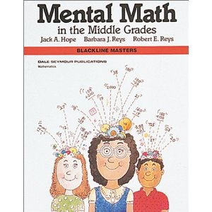
2. Adapt what we know works in our **reading programs** and apply it to mathematics instruction. 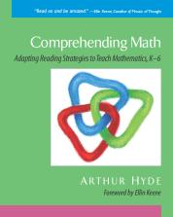
3. Use **multiple representations** of mathematical entities.

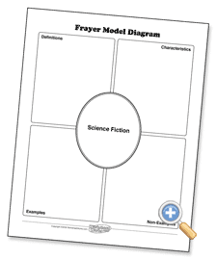

1. Create **language-rich** classroom routines.

I think…

I wonder…

**WORD WALL**

function

coefficient

equal

term

Tell the person beside you 3 things you know about…

1. Build from **graphs, charts and tables**.

C:\Documents and Settings\jdeboice\Local Settings\Temporary Internet Files\Content.IE5\FX3YIQ3K\MC900290890[1].wmf 

1. Tie the math to such questions as: How big? How much? How far? To increase the natural use of **measurement** throughout the curriculum.

 C:\Documents and Settings\jdeboice\Local Settings\Temporary Internet Files\Content.IE5\H82RPR9K\MC900232188[1].wmf 

1. Incorporate ongoing **cumulative review** into every day’s lesson.

C:\Documents and Settings\jdeboice\Local Settings\Temporary Internet Files\Content.IE5\H82RPR9K\MC900071185[1].wmf

1. Minimize what is no longer important, and teach what is important when it is appropriate to do so *(new IRP already has!)*
2. Embed the mathematics in **realistic problems** and real-world contexts.

*So, what questions arise from these data or this situation?*

**When**  and  **where** do normal human beings encounter the math I need to teach?

10. Make “Why?” “How do you know?” “Can you explain?” classroom **mantras.**

**Why?**

**How do you know?**

**Can you explain….?**